TASK 9 – Abstract Classes and Interfaces

Aim
To understand abstract classes and interfaces in Java and implement them in the Campus Smart-Parking System.

1. Abstract Class
An abstract class is declared using the abstract keyword. It can contain both abstract methods and normal methods. An abstract class cannot be instantiated directly.

2. Java Program
abstract class Vehicle {
String vehicleNo;
Vehicle(String vehicleNo) {
this.vehicleNo = vehicleNo;
}
abstract double calculateFee();
void display() {
System.out.println("Vehicle No: " + vehicleNo);
}
}
interface Chargeable {
void charge();
}
class ElectricCar extends Vehicle implements Chargeable {
ElectricCar(String vehicleNo) {
super(vehicleNo);
}
@Override
double calculateFee() {
return 60;
}
@Override
public void charge() {
System.out.println("Electric Car Charging");
}
}
public class Main {
public static void main(String[] args) {
ElectricCar e = new ElectricCar("TN01AB1234");
e.display();
System.out.println("Parking Fee: " + e.calculateFee());
e.charge();
}
}
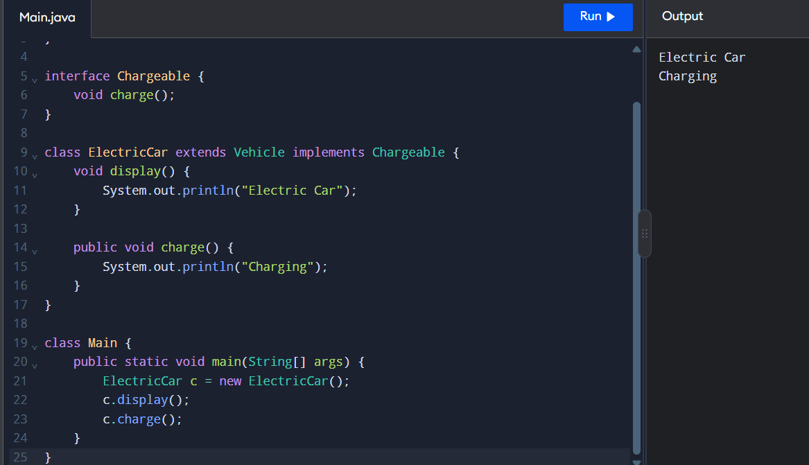

3. Expected Output
Vehicle No: TN01AB1234
Parking Fee: 60.0
Electric Car Charging

4. Explanation
- Abstract class: Provides common properties and methods for related classes.
- Abstract method: A method declared without a method body.
- Interface: Defines a contract that implementing classes must follow.
- extends: Used by a class to inherit an abstract class.
- implements: Used by a class to implement an interface.
- super(): Calls the parent-class constructor.
- @Override: Indicates that a method implements or overrides an inherited method.

5. Abstract Class vs Interface

Abstract Class | Interface
Declared using abstract class. | Declared using interface.
Can have instance variables. | Fields are implicitly public static final.
Can have constructors. | Cannot have constructors.
A class can extend only one class. | A class can implement multiple interfaces.
Example: Vehicle. | Example: Chargeable.

Result
An abstract class and an interface were implemented successfully. The program demonstrates abstraction, inheritance, method overriding, and interface implementation in Java.

